ANTLER RIDGE
HUNTING GEAR PACKING LIST

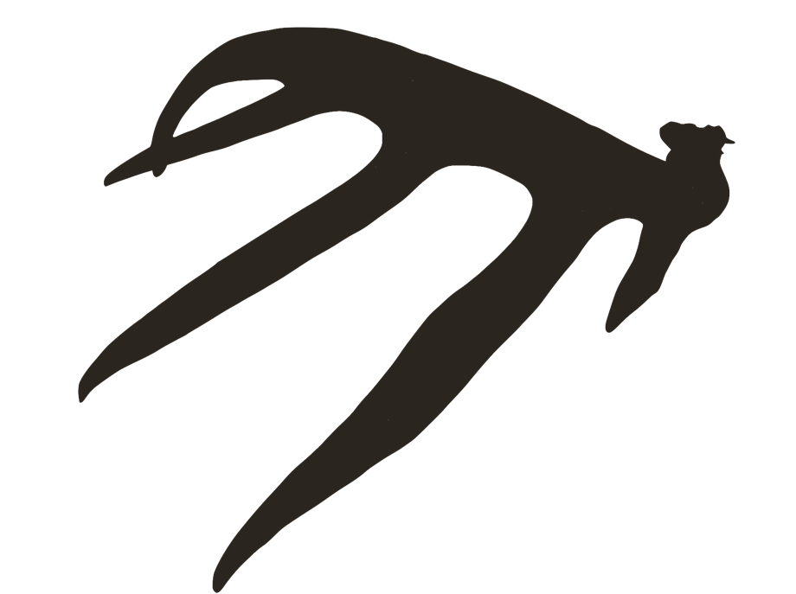
- Bow/Shotgun/Crossbow/ Muzzleloader
- Arrows/Ammo/Primers
- Quiver
- Broadheads
- Case
- Arm Guard
- Sling
- Release
- Face Camo
- Warm Weather Camo Tops and Bottoms
- Cold Weather Camo Tops and Bottoms
- Bibs
- Hand Muff
- Socks & Underwear
- Ball Cap/Hat
- Blaze Orange Hat/Vest
- Boots
- Boot Dryer
- Gloves
- Backpack
- Decoys
- First Aid
- Hand Warmers
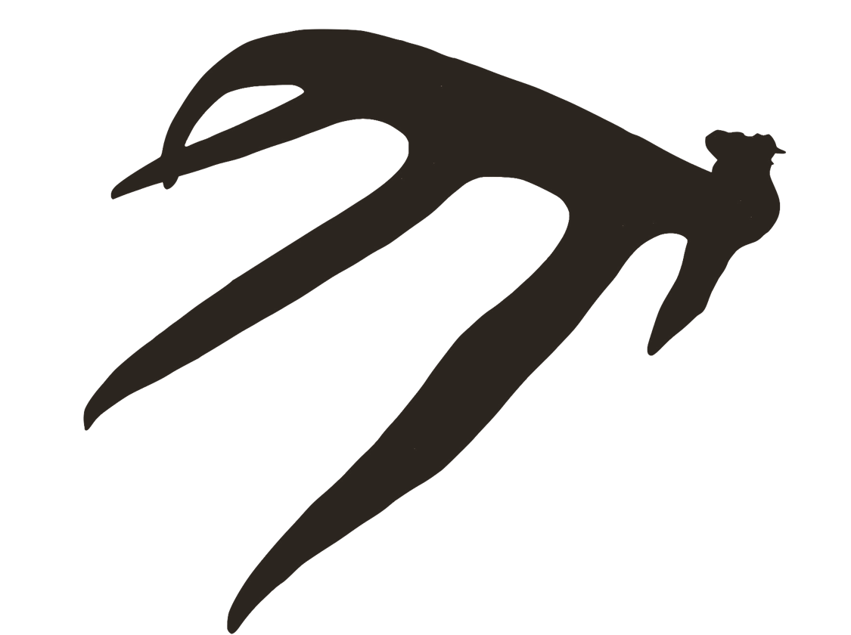
- Trail Cameras/batteries/sd cards
- Bikes/E-Bikes
- Deer Stands
- Climbing Sticks
- Tree Saddle/Platform
- Rangefinder
- Binoculars
- Wind Checker
- Bow/Gun Hoist Ropes
- Tow Ropes
- Deer Sled/Cart
- Knife/Dressing gloves/Flagging tape
- Hand Saw/limb saw
- Ratchet Straps
- Rain Suit
- Video/Photo camera, Mics, tree Camera Arms, tripods, batteries
- FlashLights & Batteries
- Scent free sprays, detergents, shampoo
- Deer Scents
- GPS
- Urine Bottle
- Spotting Scope
- Offline Maps/printed/topo maps/Compass
- Seat Cushion
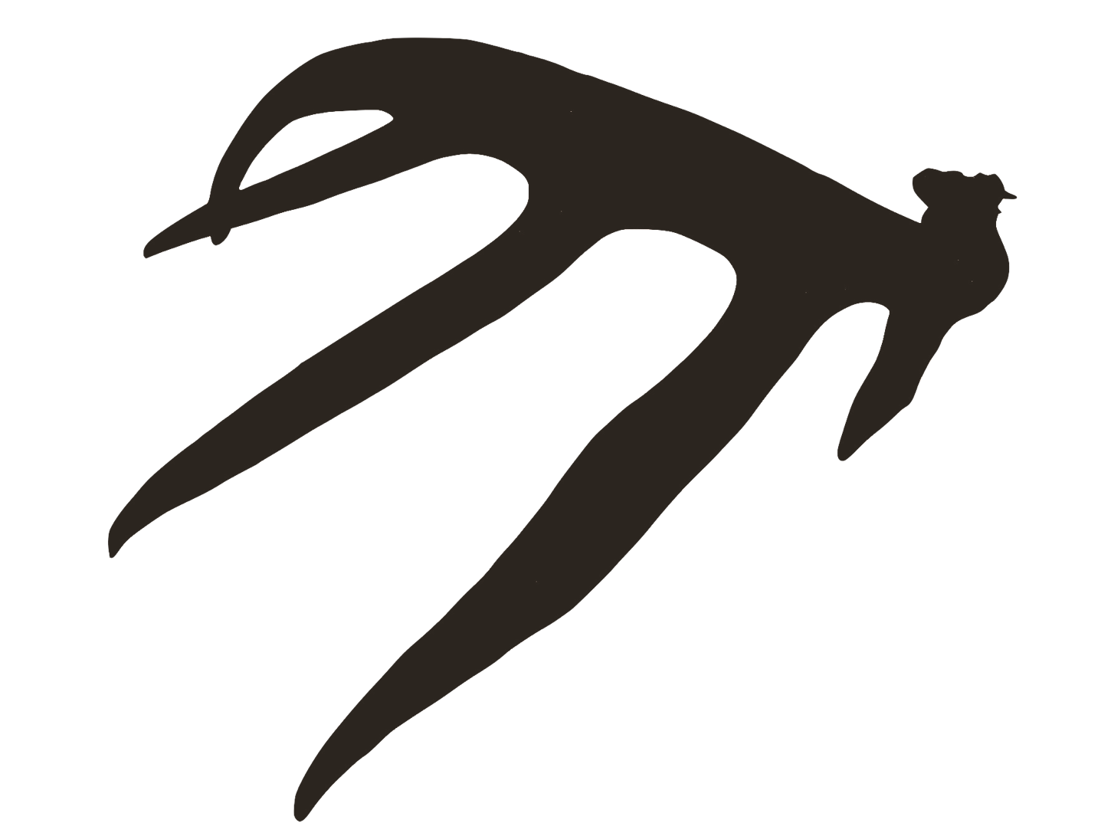
- Hunting Licenses
- Grunt Calls/Rattling Antlers
- Archery Target
- Ground Blinds
- Tree/bow Hangers
- Ozone Generator
- Safety Strap
- Lifeline
- Gun Cleaning Kit
- Allen Wrenches
- Reflector Tacks
- Portable Bow Press
- String Wax

DEER CAMP PACKING LIST
- Shirts
- Shorts
- Sweatpants/Pants
- Sweatshirt/Hoodie
- Underwear
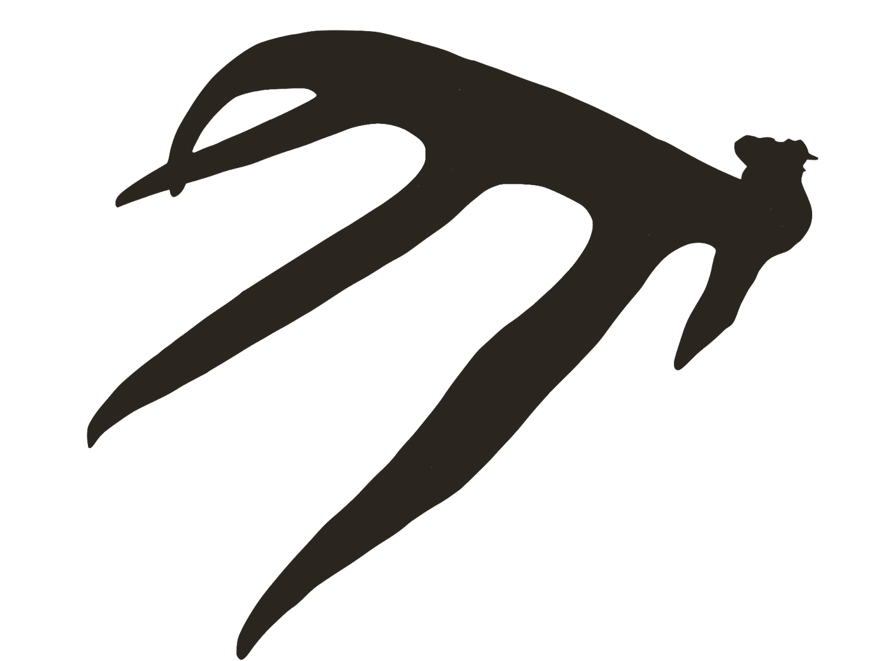
- Warm Weather Jacket
- Cool Weather Jacket
- Shoes
- Socks
- PJ's
- Longsleeve Shirt
- Toothbrush/floss/toothpaste
- Comb
- Shampoo/soap
- Deodorant
- Crockpot
- Food for meals (Fridge Provided)
- Water/Beverages
- Ice
- Cooler
- Snacks
- Computer/tablet
- Charging Chords
- External Battery
- Antler Scoring Tools
- Books/Reading Material
- Pain Meds
- Meds/Medical Supplies
- Heat/Cool Packs
- Sunglasses
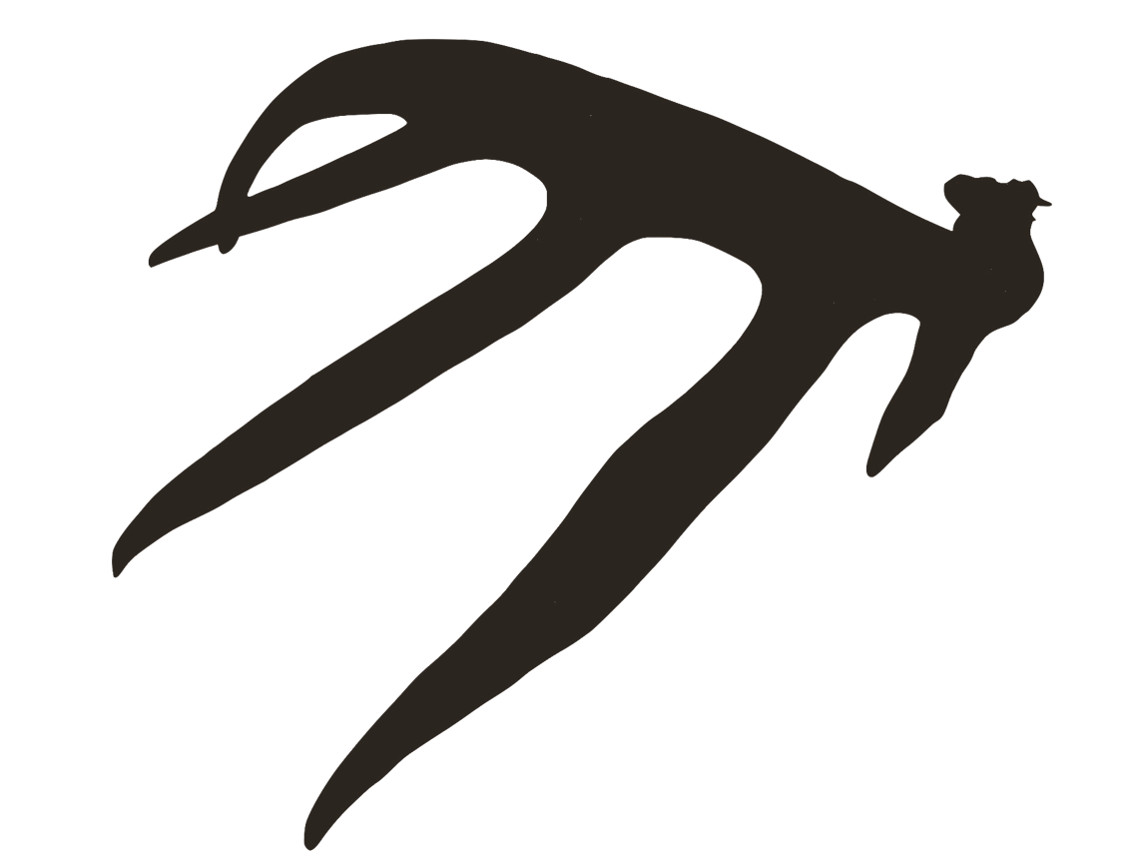
- Glasses/Contacts
- Duct Tape
- Sleeping Bag/Blankets
- Pillow
- Meat Cutting Table/board/knife
- Meat Cooler
- Meat Grinder
- Ziplocs
- Tire Patch kit/air compressor
- Car jack
- Extra Car Keys
- Wallet

THINGS TO DO
- Purchase Hunting License
- Book Hunt
- Site in Bow/gun
- Download offline maps
- Cyber scout properties
- Brush up on hunting regulations
- Inspect gear for safety
- Oil change
- Check fluid levels
- Check Tire pressure
- Strap down everything
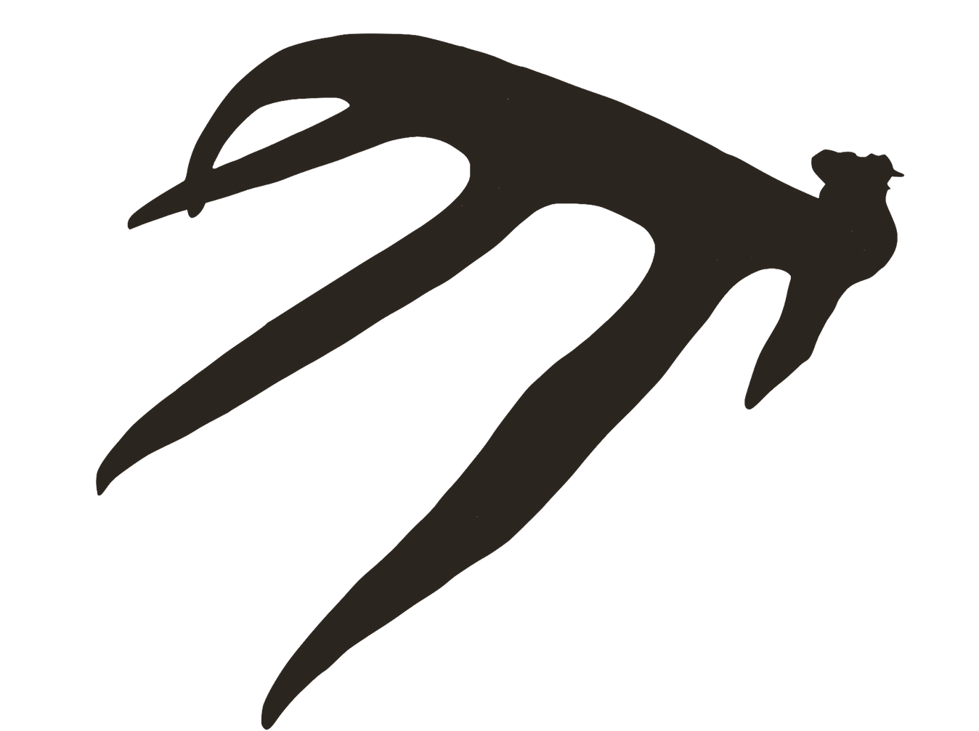
- Tell your spouse about the hunt...

